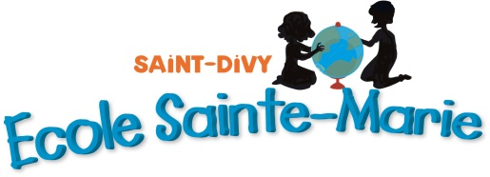
Ecole primaire Ste Marie,
2 rue du Kef,
Saint-Divy, 29800
France

The 14th of April, 2023.

Hello Sir,
We are 28 French pupils from the age of 3 to 6 years old, learning English at St Marie primary school in St Divy (Brittany, FRANCE).
From the past couple of weeks, we learnt many things about the British culture. Our ultimate experience was to write you a letter to find out more about London, the King, and his habits.
First of all, we wanted to congratulate you for your upcoming coronation. We wish you all the best for your reign; hope it will be as outstanding as your predecessor, your Majesty the Queen. Long live the King!
Indeed, we wanted to know if you are actually living at Buckingham Palace or if you have another place to live?
Moreover, London is a wonderful city, full of great monuments, which we had the opportunity to discover through two novels: “The Queen’s Hat” written by Steve Antony and “Paddington at the Palace” written by Michael Bond. Do you happen to have a favourite one amongst all of the monuments in London? And have you ever been inside the Big Ben?
As French students we needed the special help of someone who knows a lot about Great Britain, and who else than Paddington the Bear is best suited to do it. We saw videos on the Internet, where the Queen Elizabeth II and Paddington had the honour to enjoy a cup of tea together for the Queen’s Jubilee. Do you personally know him like the Queen did? Is he fun to be around?
Finally, we were curious to be informed about whether or not you know Brittany and if by any chance you have already been there? If so, how did you find it?

Thank you, your Majesty, for your time.
Kindly,
St Marie’s pupils and teachers

